FOVANT YOUTH CLUB
at the Waterside, Fovant High Street

Open to all 11 to 16 year olds from Fovant
and surrounding villages

Starting on Friday 9th September 2022
and weekly during term time

6pm to 8pm

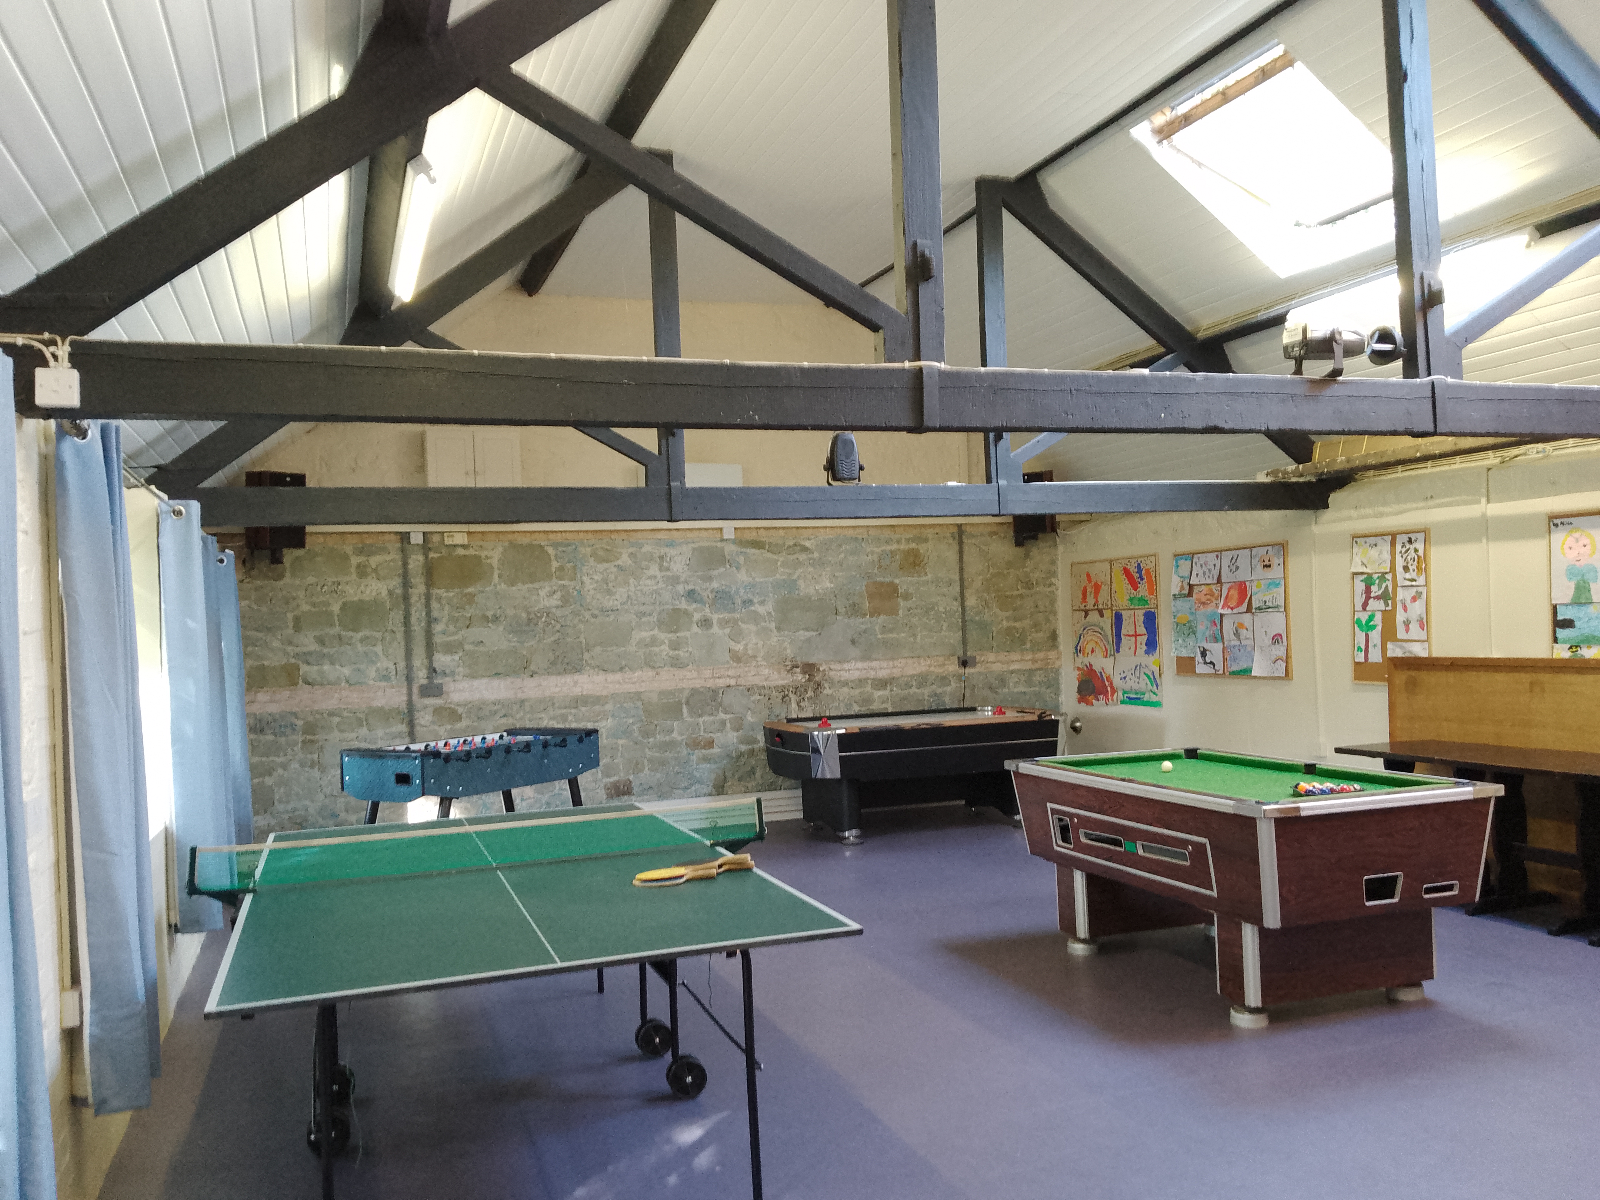

Games, board games, music, a tuck shop which will be open
from 7.00 to 7.30pm to buy snacks and above all, just
chilling out with friends after a hard week at school in
our newly restored building.

Cost per session is £1.00 per young person
For further details please contact mandy.bastin@yahoo.co.uk

