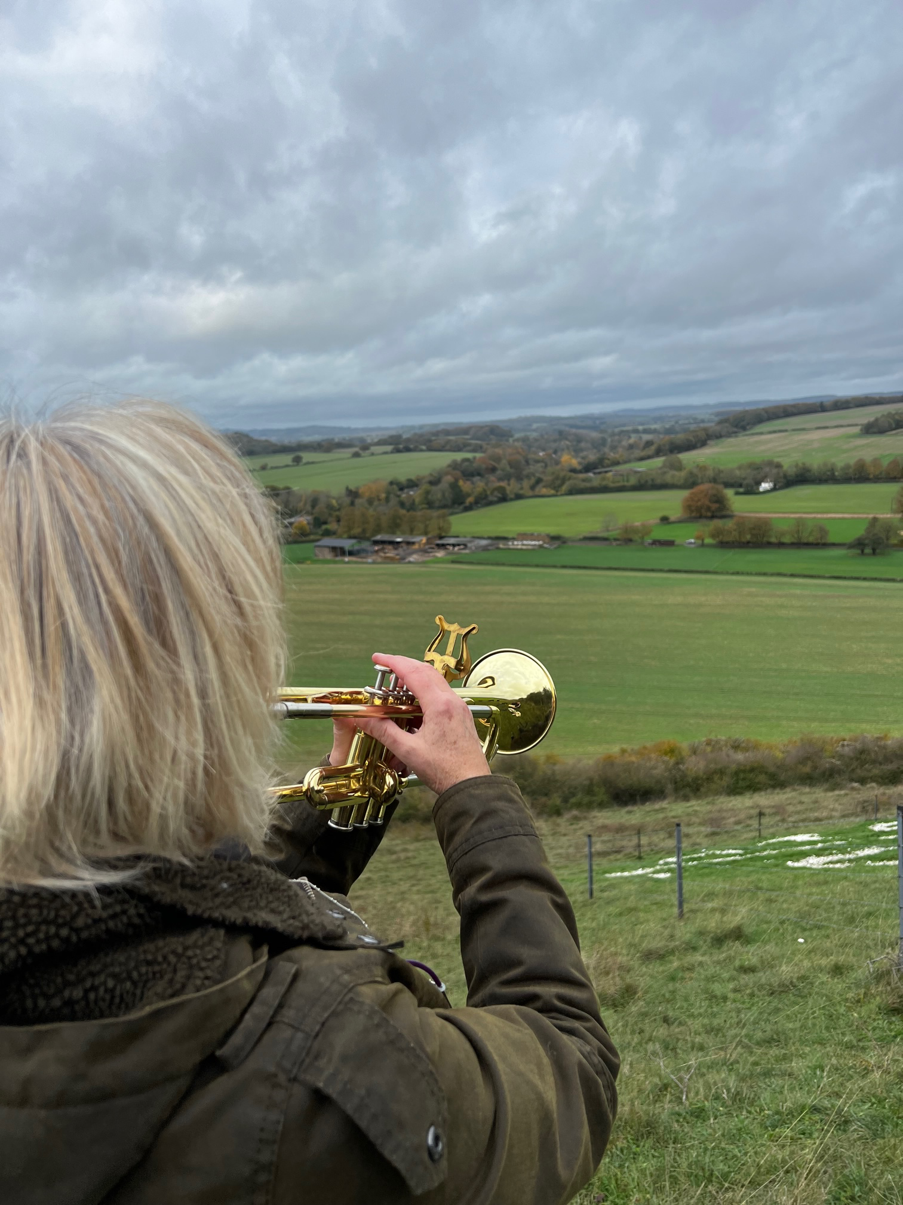
The Commemorative Poppy at Fovant Down
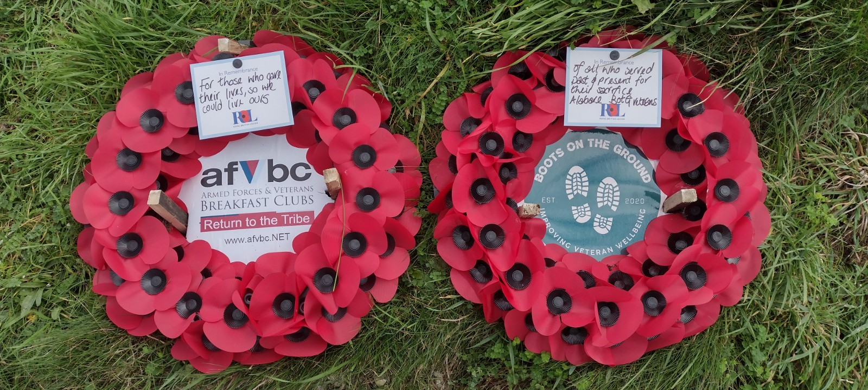
Armistice Day 11/11/2022
The locally based nationwide charity Alabaré held a commemorative ceremony to honour the memory of the fallen this year at The Fovant Badges, appropriately laying wreaths on the escarpment’s Centenary Poppy emblem in the heart of Cranbourne Chase AONB.
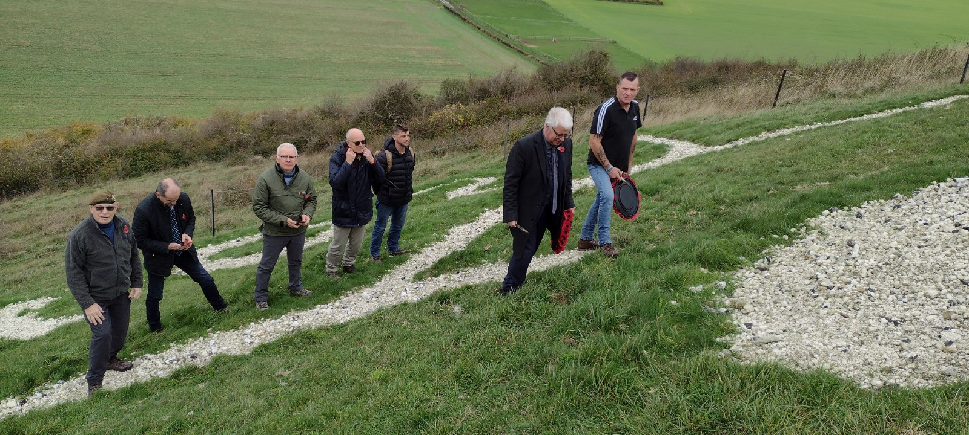
Alabaré had assisted The Fovant Badges Society in their maintenance work this year, working on the Royal Signals and Poppy compounds as part of their Boots on the Ground initiative with ex-services personnel. Alabaré brought some of their ex-services veteran residents to help with this work, some of whom are estranged from their home locations. Ed and Sue Williams, the landowners, kindly agreed to the suggestion of a commemoration, and in the bright but overcast morning Mr Andrew Lord, CEO of Alabaré, and Mr. Neil Barr on behalf of Alabaré’s residents and veterans laid wreaths. On a practical note these were pegged down against the autumn gales !
Ms Wendy Jobbins, herself an ex-services musician, added a touching poignancy to the ceremony by playing The Last Post, then Reveille, her cornet sounding out over the site of WW1 Fovant Camps on East Farm and the A30 in the valley below.
Leslie Brantingham FBS

